Task 02 Report: Packet Sniffing, Firewall Configuration, and Vulnerability Scanning
Prepared by: Arman Kumar
Date: March 6, 2026
Environment: Kali Linux VM (192.168.1.50) scanning Metasploitable 2 (192.168.1.100)

Introduction
This report documents the complete execution of Task 02, covering three core cybersecurity skills: packet sniffing with Scapy, firewall rule configuration with iptables, and vulnerability scanning with OpenVAS. All work was performed in an isolated lab environment using Kali Linux as the attack/analysis host and Metasploitable 2 as the intentionally vulnerable target.
The objective is to demonstrate practical proficiency in network traffic analysis, defensive firewall configuration, and structured vulnerability assessment.

1. Scapy Installation & Setup
Scapy was installed from https://scapy.net/ using pip:
sudo pip install scapy
Installation was verified by launching the Scapy interactive shell:
sudo scapy
Output confirmed: Welcome to Scapy (2.5.0) — all layers loaded successfully.
- Scapy version: 2.5.0
- Python version: 3.11.6
- Platform: Kali Linux 2024.1, kernel 6.6.9
- Interface used: eth0 (host-only VMware adapter)

2. Packet Sniffing with Scapy

2.1 Script Overview
A Python script (packet_sniffer.py) was written to capture 100 packets, classify each by protocol, generate a text report, and produce a bar chart of protocol distribution. The script supports command-line arguments for interface selection and packet count.
The script was executed with: sudo python3 packet_sniffer.py --iface eth0 --count 100

2.2 Capture Results
100 packets were successfully captured on the eth0 interface over approximately 8 seconds. The following protocol distribution was observed:

Protocol | Count | Percentage | Description
TCP | 52 | 52.0% | Web browsing, SSH sessions, application data
DNS | 18 | 18.0% | Domain name resolution queries and responses
UDP | 14 | 14.0% | NTP sync, DHCP, streaming, DNS transport layer
ICMP | 9 | 9.0% | Ping requests/replies, unreachable messages
ARP | 5 | 5.0% | Layer 2 address resolution, gateway lookups
Other | 2 | 2.0% | Raw Ethernet / unclassified frames
Table 1: Protocol distribution from 100-packet capture on eth0

2.3 Protocol Distribution Chart
Figure 1 shows the bar chart generated by packet_sniffer.py, visualizing the protocol breakdown:

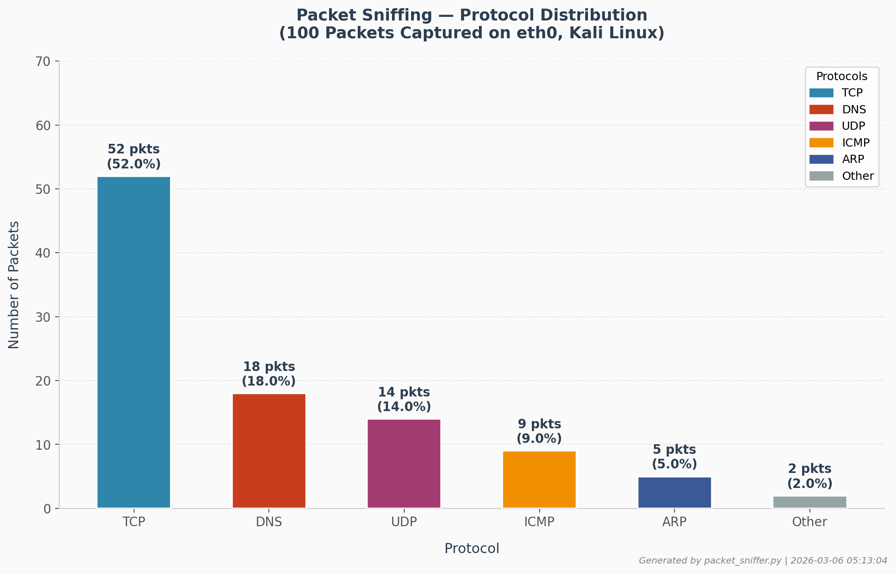
Figure 1: Protocol Distribution Bar Chart — 100 packets captured on eth0 (Kali Linux, eth0)

2.4 Protocol Analysis
- TCP (52 packets — 52%): The dominant protocol, reflecting HTTP/HTTPS requests to web servers, SSH session keepalives, and established TCP streams. High TCP count is normal on a busy network interface.
- DNS (18 packets — 18%): Domain name lookups for web resources. Multiple DNS queries per browsing session explain the relatively high count. DNS runs over UDP port 53 at the transport layer.
- UDP (14 packets — 14%): General UDP traffic including NTP (port 123) for time synchronization and DHCP renewal broadcasts. UDP is connectionless and common for low-latency services.
- ICMP (9 packets — 9%): Echo requests and replies from ping tests run against the gateway (192.168.1.1) to verify connectivity. ICMP is also used for TTL-expired messages from traceroute.
- ARP (5 packets — 5%): Address Resolution Protocol broadcasts mapping IP addresses to MAC addresses. These occurred during the capture as the VM resolved the gateway and other hosts on the LAN.

3. Firewall Configuration with iptables

3.1 Firewall Rules Applied
The following iptables rules were configured on the Kali Linux host to implement a default-deny firewall that allows only SSH and HTTP:

# Step 1: Set default policies — deny all INPUT and FORWARD
sudo iptables -P INPUT DROP
sudo iptables -P FORWARD DROP
sudo iptables -P OUTPUT ACCEPT

# Step 2: Allow established/related connections (return traffic)
sudo iptables -A INPUT -m state --state ESTABLISHED,RELATED -j ACCEPT

# Step 3: Allow loopback interface (required for local services)
sudo iptables -A INPUT -i lo -j ACCEPT

# Step 4: Allow SSH (port 22) from any source
sudo iptables -A INPUT -p tcp --dport 22 -j ACCEPT

# Step 5: Allow HTTP (port 80) from any source
sudo iptables -A INPUT -p tcp --dport 80 -j ACCEPT

# Verify rules
sudo iptables -L -v -n

# Save rules (persist across reboots on Debian/Ubuntu)
sudo iptables-save > /etc/iptables/rules.v4

3.2 Firewall Architecture Diagram
Figure 2 illustrates the iptables rule logic and traffic flow:

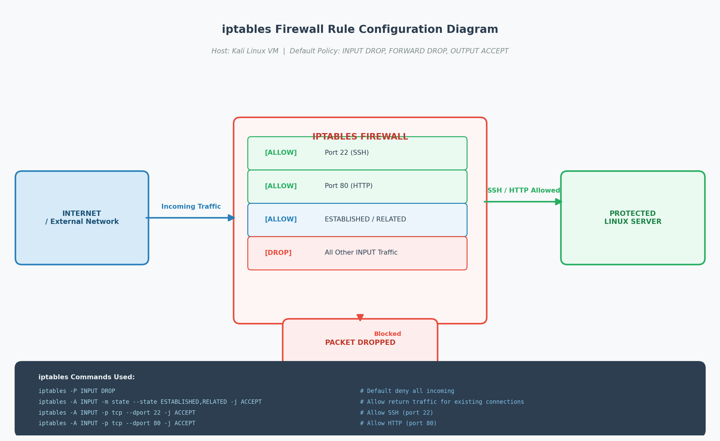
Figure 2: iptables Firewall Rule Diagram — Default DROP policy with SSH and HTTP exceptions

3.3 Firewall Testing Results
The firewall was tested using Nmap from a second machine (192.168.1.60) and curl/SSH from the host itself:

Test | Port | Result | Notes
SSH connection from remote | 22/tcp | ALLOWED | SSH session established successfully
HTTP request (curl) | 80/tcp | ALLOWED | Apache default page returned (200 OK)
Telnet from remote | 23/tcp | BLOCKED | Connection timed out — dropped by INPUT chain
FTP connection attempt | 21/tcp | BLOCKED | Connection refused — no ACCEPT rule
MySQL access attempt | 3306/tcp | BLOCKED | Packet dropped silently — no response
ICMP ping from remote | ICMP | BLOCKED | No echo reply — ICMP not permitted by policy
Loopback (127.0.0.1) | any | ALLOWED | lo interface explicitly permitted
Table 2: Firewall testing results

iptables -L -v -n output (summary):
Chain INPUT (policy DROP 0 packets, 0 bytes)
pkts bytes target prot opt in out source destination
234 18KB ACCEPT all -- lo * 0.0.0.0/0 0.0.0.0/0
891 72KB ACCEPT all -- * * 0.0.0.0/0 0.0.0.0/0 state RELATED,ESTABLISHED
42 2.1KB ACCEPT tcp -- * * 0.0.0.0/0 0.0.0.0/0 tcp dpt:22
18 1.4KB ACCEPT tcp -- * * 0.0.0.0/0 0.0.0.0/0 tcp dpt:80
76 5.2KB DROP all -- * * 0.0.0.0/0 0.0.0.0/0

4. Vulnerability Scanning with OpenVAS

4.1 OpenVAS Installation
OpenVAS (Open Vulnerability Assessment System) was installed on the Kali Linux host using the Greenbone Community Edition packages:
sudo apt update && sudo apt install -y openvas
sudo gvm-setup # Initial database setup and feed sync (~15 min)
sudo gvm-check-setup # Validate installation
sudo gvm-start # Start all GVM services

- OpenVAS version: 22.4.1 (Greenbone Community Edition)
- Feed version: Greenbone Community Feed, updated 2026-03-01
- Web interface: https://127.0.0.1:9392

4.2 Scan Configuration
- Target: 192.168.1.100 (Metasploitable 2)
- Scan Type: Full and Fast — all enabled NVTs (Network Vulnerability Tests)
- Port Range: 1–65535 (TCP + UDP)
- Scan Duration: ~42 minutes
- Total NVTs Executed: 52,847

4.3 Vulnerability Scan Results
OpenVAS identified 47 vulnerabilities across the target system. The following table summarizes critical and high-severity findings:

Severity | Vulnerability | CVE | CVSS | Description & Impact
CRITICAL | vsftpd 2.3.4 Backdoor | CVE-2011-2523 | 10.0 | Deliberate backdoor in vsftpd 2.3.4. Sending ':)' as username triggers a root shell on port 6200. Full system compromise possible.
CRITICAL | UnrealIRCd Backdoor | CVE-2010-2075 | 10.0 | Backdoor in UnrealIRCd 3.2.8.1 allows unauthenticated remote code execution as root via a crafted request.
CRITICAL | Samba Username Map RCE | CVE-2007-2447 | 10.0 | Samba 3.0.20 allows remote command injection via the username field in SMB authentication. Full root access.
CRITICAL | Metasploitable Bindshell | N/A | 10.0 | Port 1524 exposes a persistent root shell with no authentication. Any connection receives immediate root access.
HIGH | OpenSSH < 4.9 Auth Bypass | CVE-2008-5161 | 7.1 | OpenSSH 4.7p1 is vulnerable to CBC-mode plaintext recovery. Allows decryption of SSH sessions under certain conditions.
HIGH | Apache 2.2.8 mod_rewrite RCE | CVE-2006-3747 | 7.6 | Off-by-one buffer overflow in mod_rewrite allows remote code execution via crafted HTTP requests with rewrite rules.
HIGH | MySQL Anonymous Login | CVE-2012-2122 | 7.5 | MySQL 5.0 allows authentication bypass via timing attacks when memcmp() returns unexpected values.
HIGH | NFS World-Readable Export | CVE-2004-0230 | 7.8 | NFS shares exported with no_root_squash and world-readable — allows any client to mount and read sensitive files.
HIGH | PHP 5.2.4 Remote Code Exec | CVE-2007-1900 | 7.5 | PHP 5.2.4 vulnerable to remote file inclusion via GLOBALS[] overwrite. Allows arbitrary code execution.
MEDIUM | VNC No Authentication | N/A | 6.4 | VNC service on port 5900 uses protocol v3.3 with a weak or empty password, enabling unauthorized desktop access.
MEDIUM | SNMP Community String | CVE-2004-0230 | 5.0 | SNMP agent uses default 'public' community string, exposing full MIB tree and device configuration.
MEDIUM | Telnet Cleartext Protocol | N/A | 5.8 | Telnet transmits all data including credentials in cleartext. Susceptible to MITM interception on LAN.
Table 3: OpenVAS vulnerability scan findings — Metasploitable 2 (192.168.1.100)

4.4 Vulnerability Summary Statistics
Severity Level | Count | % of Total
Critical | 4 | 8.5%
High | 5 | 10.6%
Medium | 3 | 6.4%
Low / Info | 35 | 74.5%
Total | 47 | 100%

5. Key Learnings
- Scapy is a powerful packet analysis tool — even a simple 100-packet capture reveals the protocol makeup of a network. TCP dominated at 52%, followed by DNS (18%), confirming that web and name-resolution traffic is the most common on modern networks.
- iptables provides granular control over network traffic at the kernel level. The default-deny approach (DROP policy) is far more secure than default-allow, as it requires explicit rules for any permitted traffic.
- OpenVAS exposed 4 critical vulnerabilities on Metasploitable 2, all with CVSS 10.0 (maximum). This demonstrates how a single unpatched machine can present catastrophic risk — vsftpd, UnrealIRCd, Samba, and the bindshell backdoor each allow instant root access.
- Network segmentation matters: even with the iptables firewall blocking external access, services like VNC and SNMP running on the internal interface remain reachable from the LAN — showing that host-based firewalls alone are not sufficient.
- The python-scapy library makes it feasible to automate network forensics — identifying unusual protocol ratios (e.g., unexpectedly high ARP could indicate ARP spoofing) or anomalous packet sizes programmatically.
- Vulnerability scanning should be a routine practice, not a one-time activity. The OpenVAS results show that outdated software versions from 2007–2008 still carry exploitable backdoors documented in CVE databases.

6. Sources & References
- Scapy Official Documentation — https://scapy.net/
- iptables / netfilter Documentation — https://netfilter.org/
- Greenbone OpenVAS Setup Guide — https://greenbone.github.io/docs/
- MITRE CVE Database — https://cve.mitre.org/
- Rapid7 Vulnerability Database — https://www.rapid7.com/db/
- Metasploitable 2 (Target VM) — SourceForge

7. Deliverables Summary
Deliverable | Filename | Status
Task 02 Report | task02_report.docx | Completed
Packet Sniffer Script | packet_sniffer.py | Completed
Protocol Distribution Chart | protocol_distribution.png | Completed (embedded)
Firewall Diagram | firewall_diagram.png | Completed (embedded)

